

**LAB 9:**

**Image/Video input interfacing with microcontroller and computer based system : Software and hardware**

**MCTA 3202**

GROUP F

GROUP MEMBERS MATRIC NO

1. Muhammad Naufal bin Mohammad Bakri 2110333
2. Muhammad Khairul Aiman bin Mohamad Basari 2113571
3. Muhammad Nabil Ikhmal Bin Khairil Rizal 2114577
4. Muhammad Zakwan Zikri bin Irwan Affandi 2111033
5. Che Muhammad Danial Bin Che Suhaimi 2119075

DATE OF SUBMISSION :

20th December 2023

**Table of Contents**

**Abstract 3**

**Introduction 3**

**Materials and Equipment 3**

**Experimental Setup 4**

**Methodology 5**

**Data Collection 6**

**Data Analysis 7**

**Results 9**

**Discussion 10**

**Conclusion 11**

**Recommendations 11**

**References 12**

**Appendices 12**

**Code Snippets 12**

**Student's Declaration 15**

## 

# **Abstract**

This experiment focuses on the integration of colour sensors and computer vision technologies to detect and respond to specific colours using microcontrollers. The study involves two primary parts: the first section employs a TCS230 colour sensor and an Arduino board to detect basic colours (red, green, and blue) and control an RGB LED accordingly. The second part utilises a Pixy Camera to identify these colours and manipulate the RGB LED based on the detected colours. The experiment explores the synergy of hardware components and software algorithms in real-time colour detection and response.

# **Introduction**

Basic elements of many applications, such as robotics and industrial automation, involve colour detection and processing. The purpose of this project is to investigate how computer vision methods and colour sensors can be combined in a system that uses a microcontroller. Red, green, and blue are the primary colours that are detected by a TCS230 colour sensor in the first stage of the experiment. In order to visually depict the detected colour, an RGB LED is controlled by the Arduino board after processing the sensor data.

In the second section, the Pixy Camera, a computer vision tool with colour signature recognition is introduced. With the help of a camera to detect colours, this sophisticated arrangement improves colour detecting capabilities by dynamically adjusting the RGB LED. The experiment highlights the potential for practical applications in domains like automation and robotics and highlights the adaptability of colour detecting methods.

# **Materials and Equipment**

Part A:

* Arduino Board
* colour Sensor(TCS230)
* Jumper Wires
* Breadboard
* RGB LED
* Computer with Arduino IDE and Python Installed
* USB cable for Arduino

Part B:

* Arduino Board
* Pixy Camera
* Computer with Arduino IDE and Python Installed
* USB cable for Arduino
* RGB LED

# **Experimental Setup**

Part A (Colour Sensor)

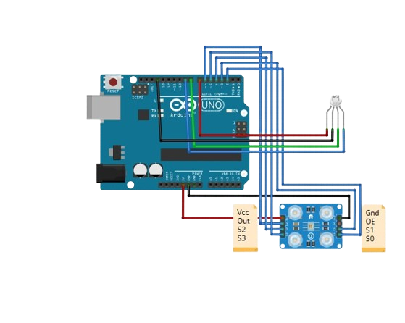

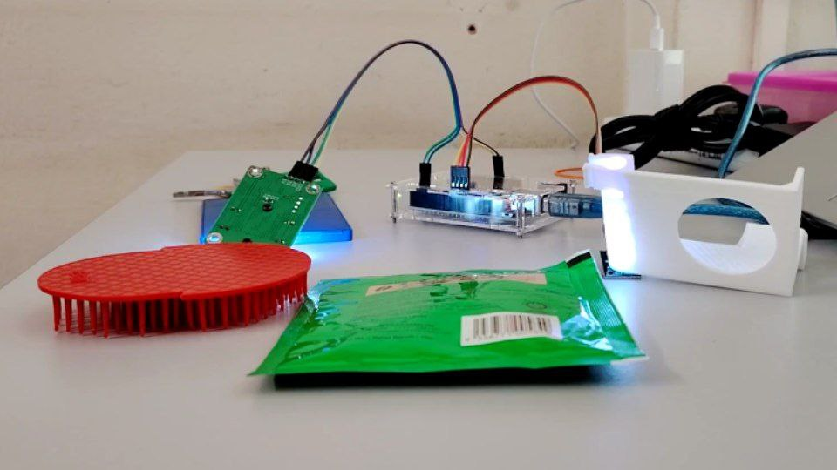

Part B (Pixy Camera)

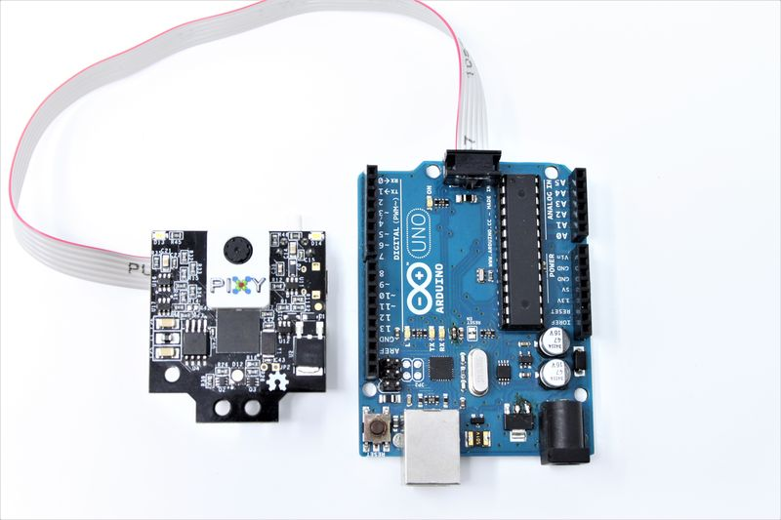

# **Methodology**

Part A (Colour Sensor)

1. Hardware Setup:

* Connect the colour sensor to the Arduino using jumper wires. Refer to the sensor's datasheet and Arduino's pinout diagrams for guidance.
* If using an RGB LED, connect it to the Arduino for colour display.

2. Arduino Programming:

* Write an Arduino sketch to interface with the colour sensor.
* Read RGB colour data from the sensor and convert it to a format that can be sent to the computer.
* Calibrate the sensor for accurate colour readings.

3. Python Programming:

* Write a Python program to communicate with the Arduino over the serial connection using the pyserial library.
* Receive RGB colour data from the Arduino.
* Interpret the received data to determine the detected colour. You can modify the code shown below for your own purposes.

4. Testing and Data Collection:

* Test the system with different coloured objects.
* Collect data on the detected colours, their accuracy, and how the system performs in various lighting conditions.
* Analyse the response time of the system when detecting colours.

5. Analysis:

* Evaluate the accuracy of colour detection by comparing detected colours with actual colours. Analyse how the system performs in different lighting conditions.
* Calculate the average response time for colour detection.

Part B (Pixy Camera)

1. Hardware Setup:

* Connect the Pixy camera to the Arduino using jumper wires. Refer to the sensor's datasheet and Arduino's pinout diagrams for guidance.
* Ensure that the Arduino Uno is powered either via USB or an external power supply.
* Before starting, you need to calibrate the Pixy camera for the three different coloured objects. Open the PixyMon software on your computer, connect the Pixy camera, and configure colour signatures for each of the three objects.

2. Arduino Programming:

* Write an Arduino sketch to interface with the Pixy camera.
* Code will read the blocks detected by the Pixy camera, prints their signatures, X, and Y coordinates, and provides a basic structure for identifying the three different coloured objects

3. Python Programming:

* Write a Python program to communicate with the Arduino over the serial connection using the pyserial library.

4. Testing and Data Collection:

* Open the Serial Monitor in the Arduino IDE (Tools -> Serial Monitor) to view the output and debug any issues
* If needed, adjust colour signatures and threshold values in the PixyMon software and the Arduino code to improve object detection.
* Add specific actions or behaviours for each detected colour based on your project requirements

# **Data Analysis**

Part A (Colour Sensor)

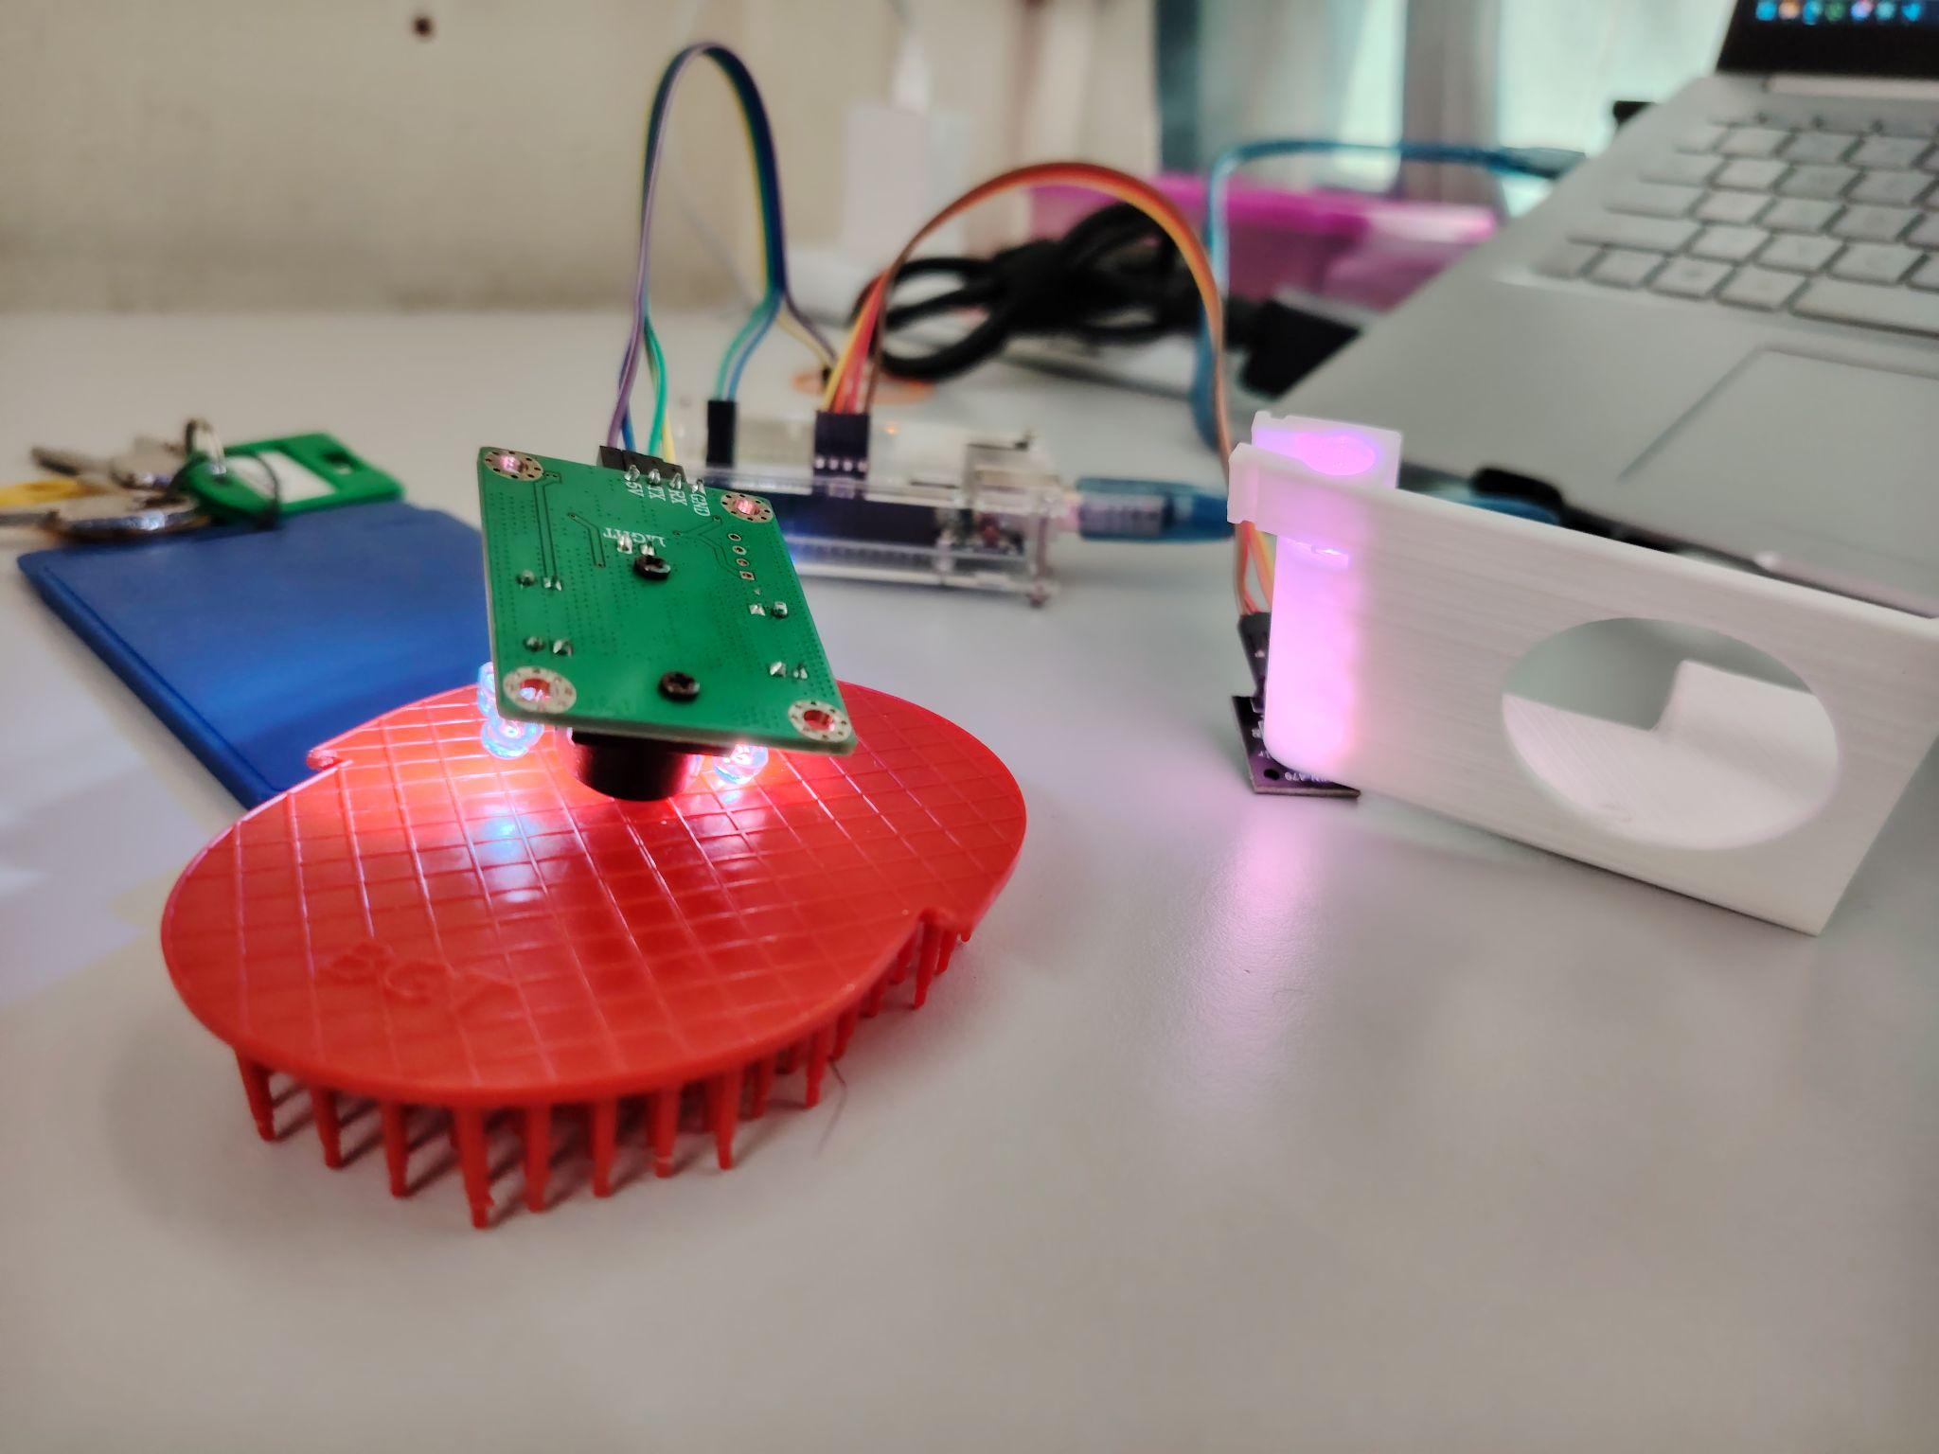

RGB lights up red when detected the colour red

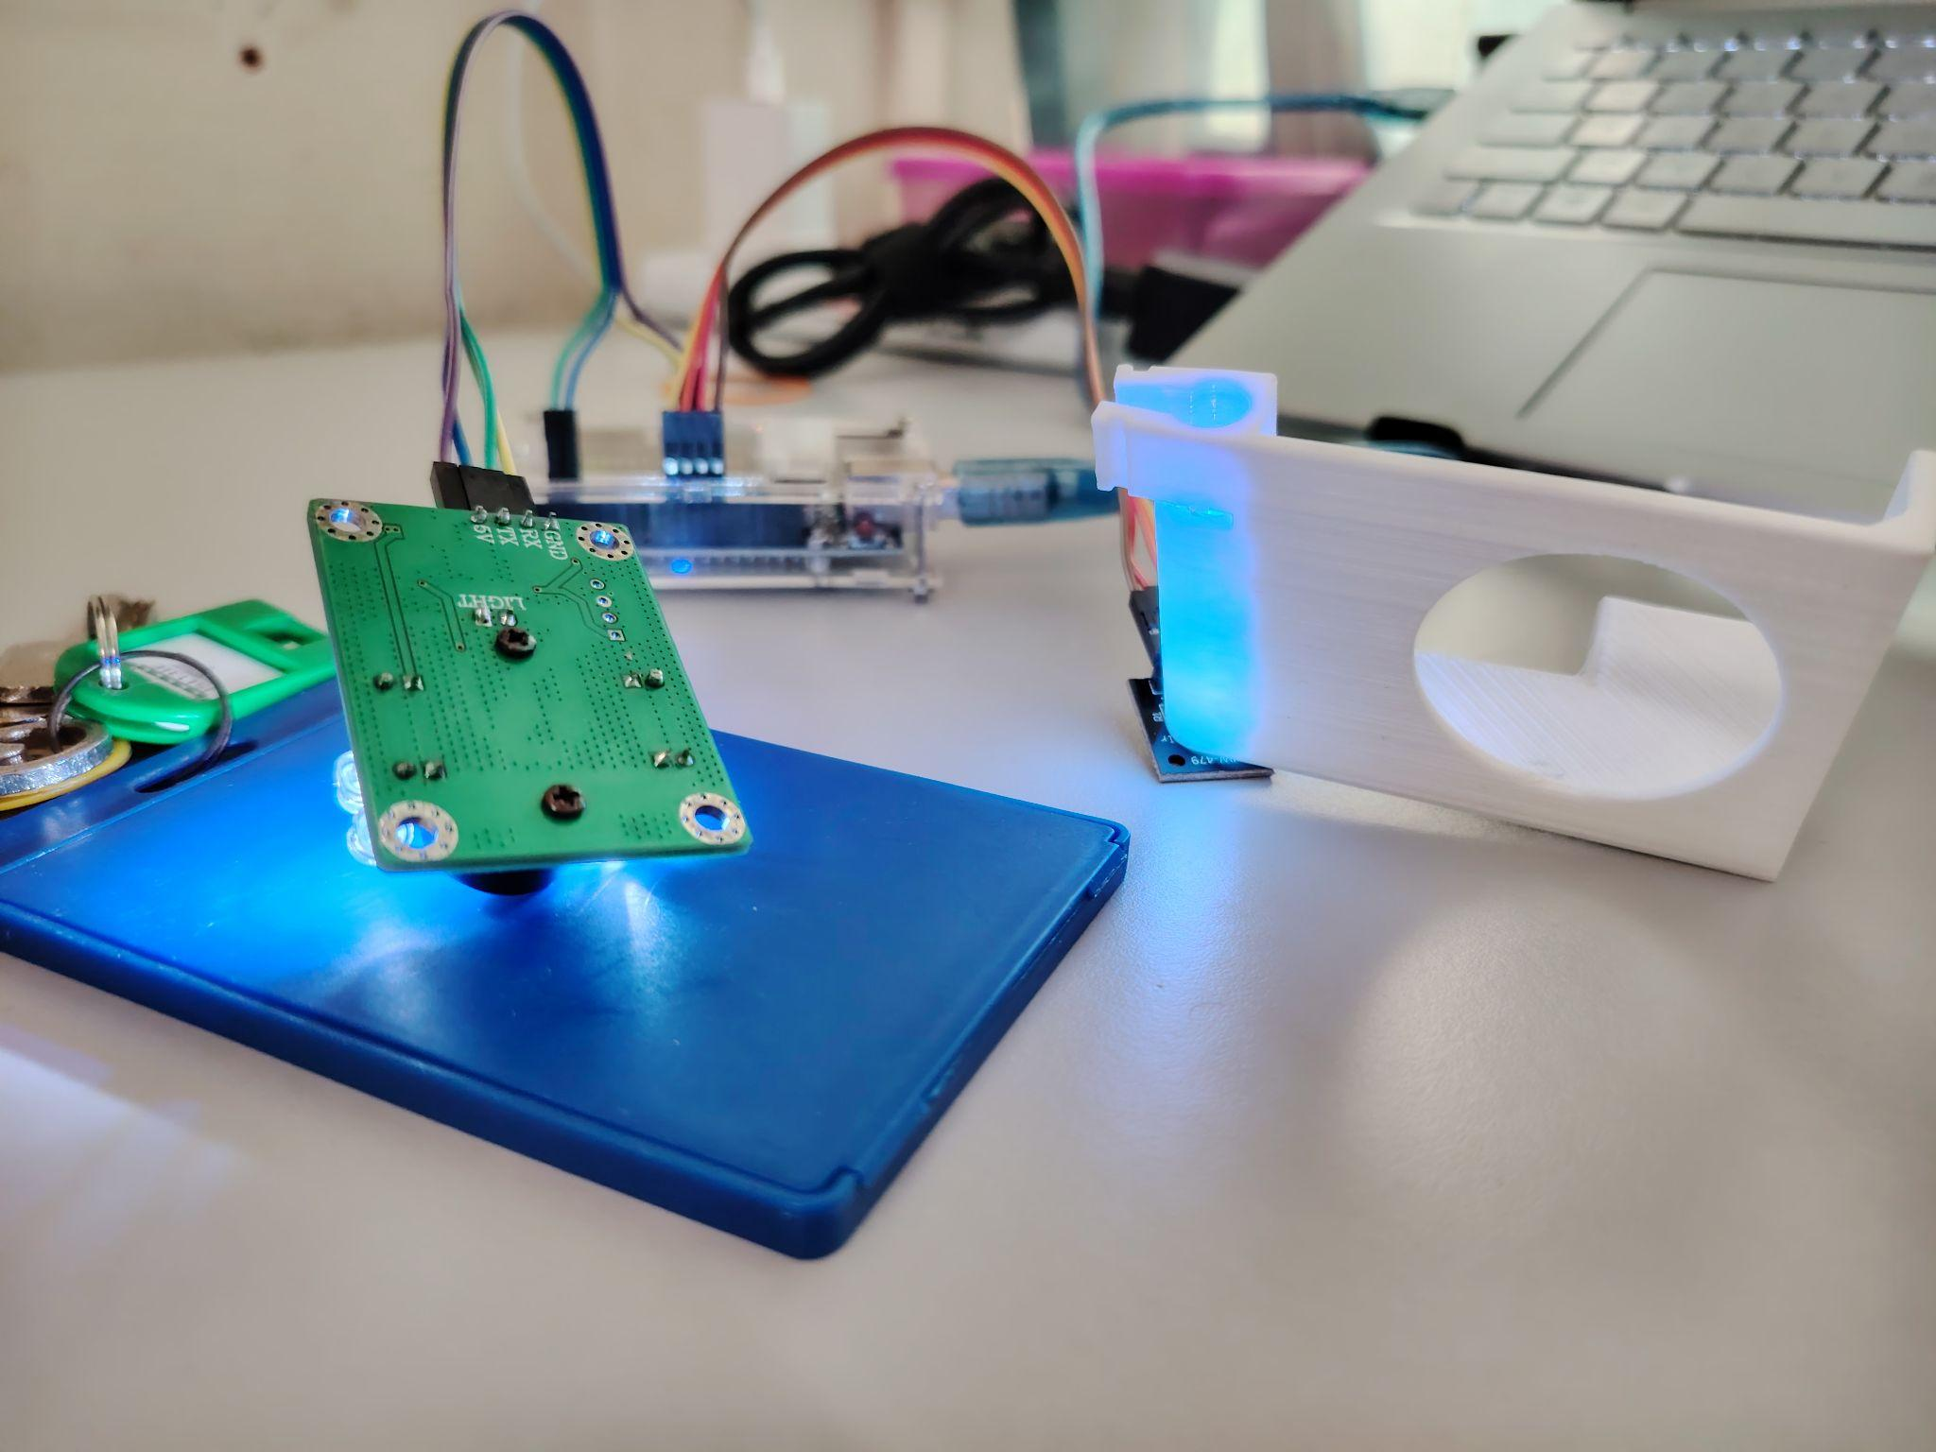

RGB lights up blue when detected the colour blue

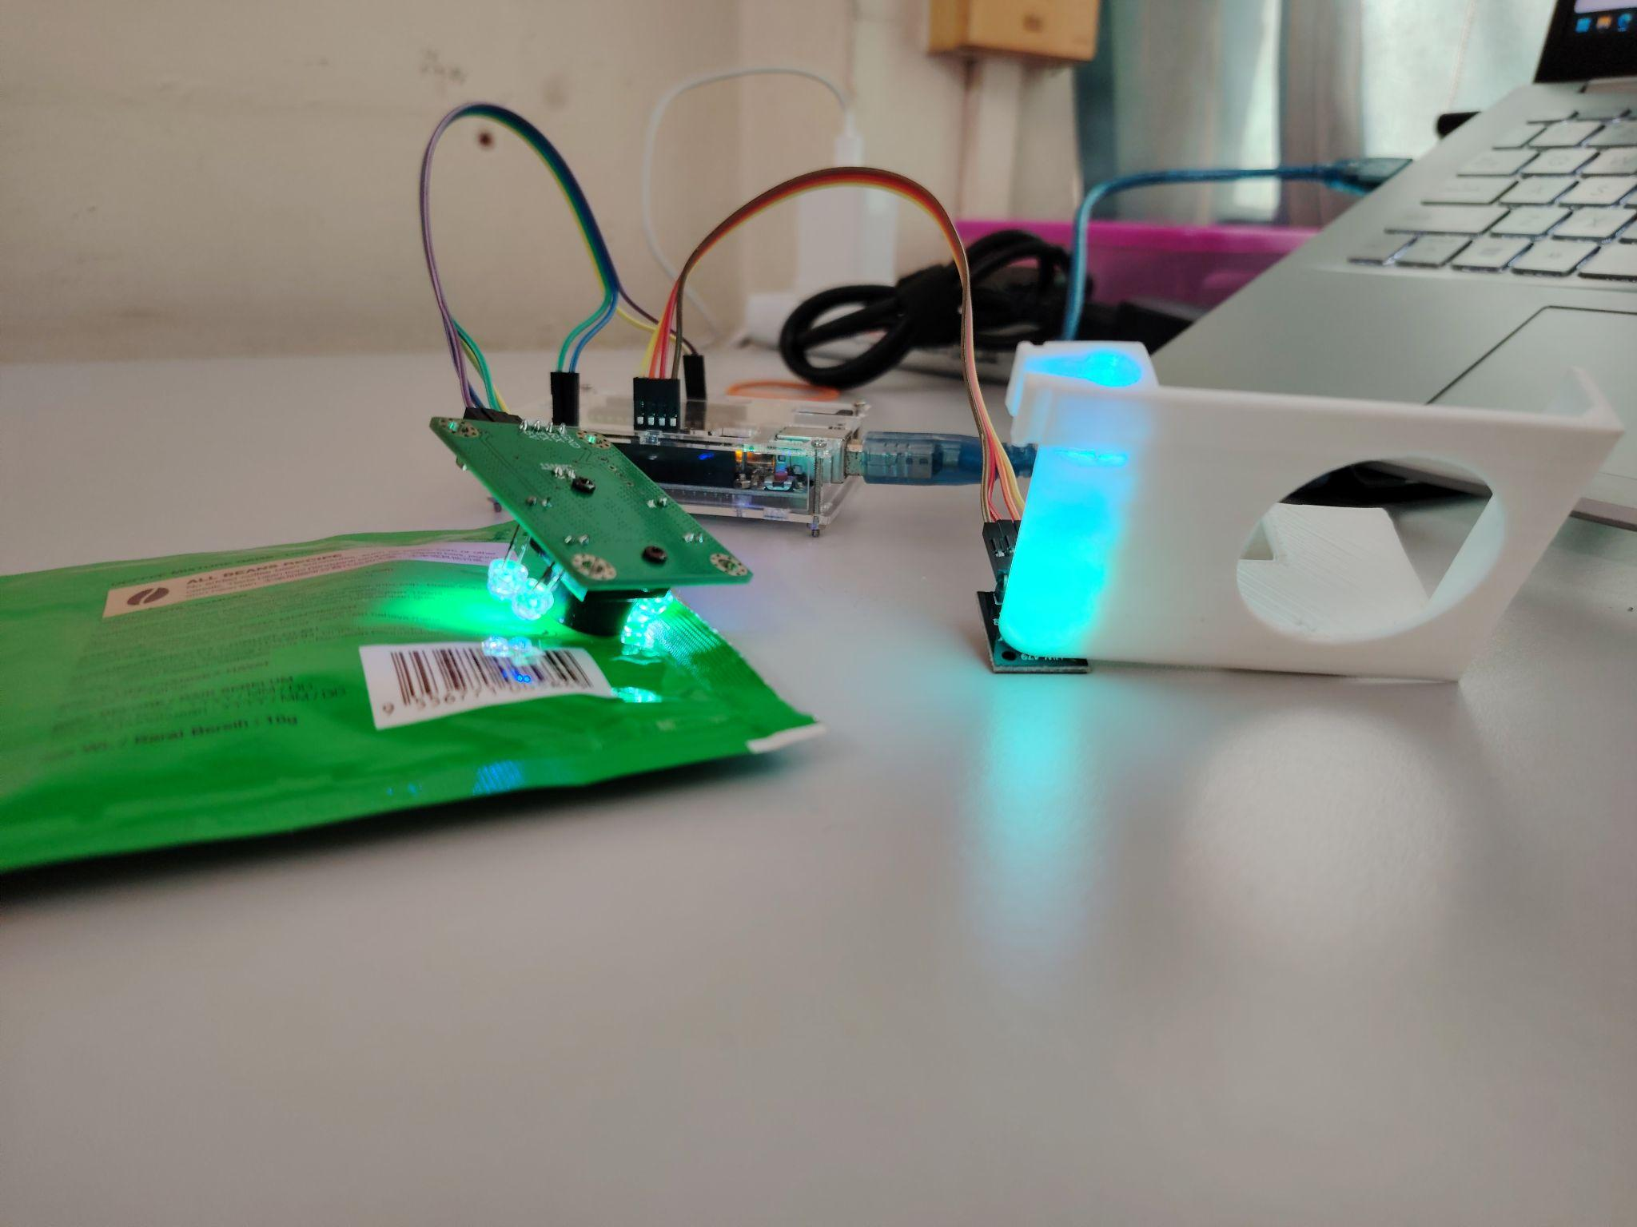

RGB lights up green when detected the colour green

Part B (Pixy Camera)

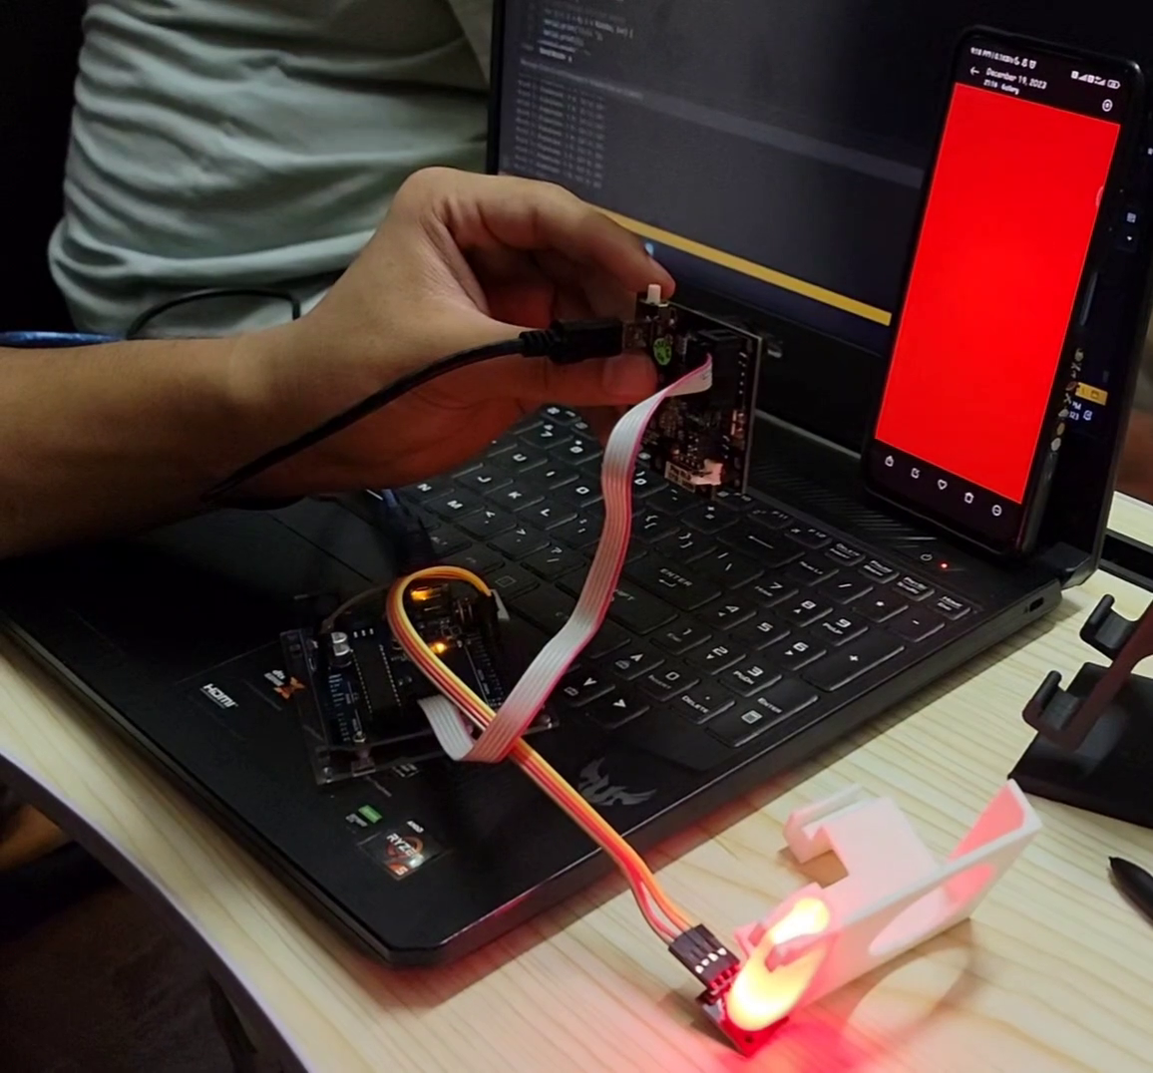

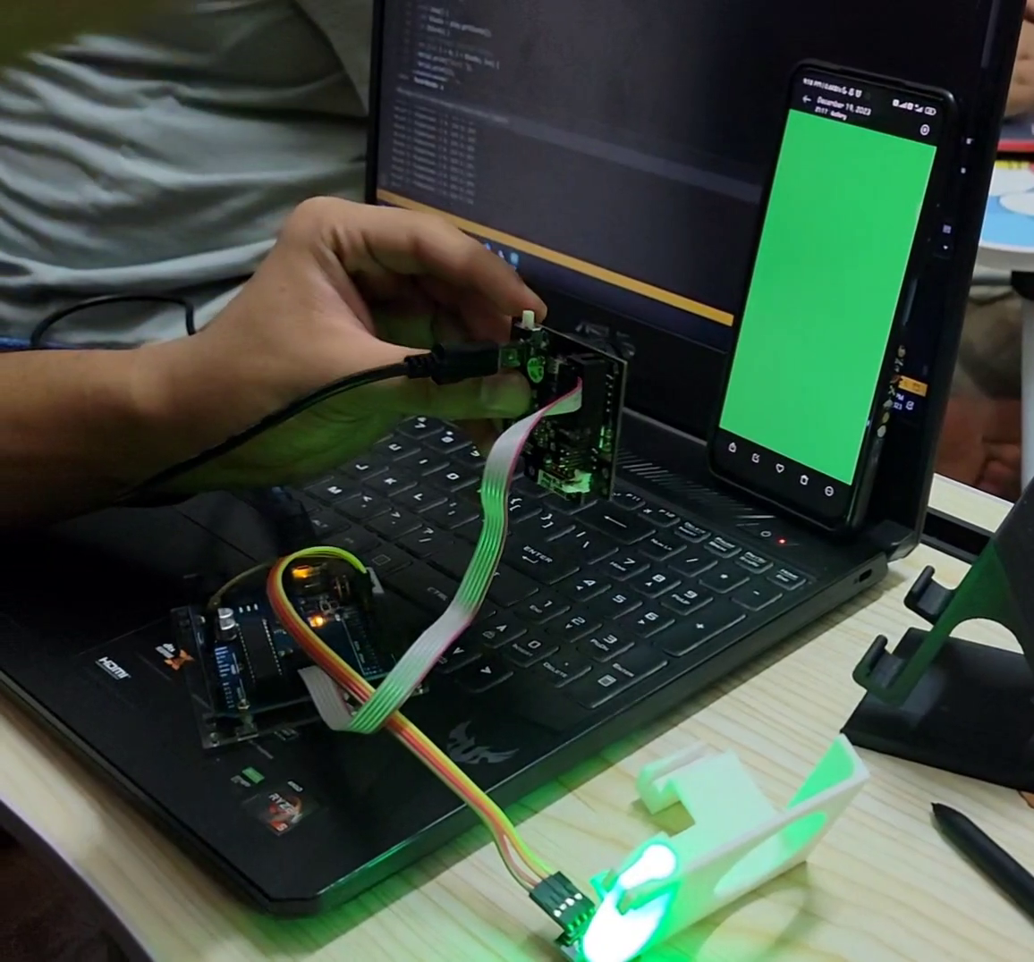

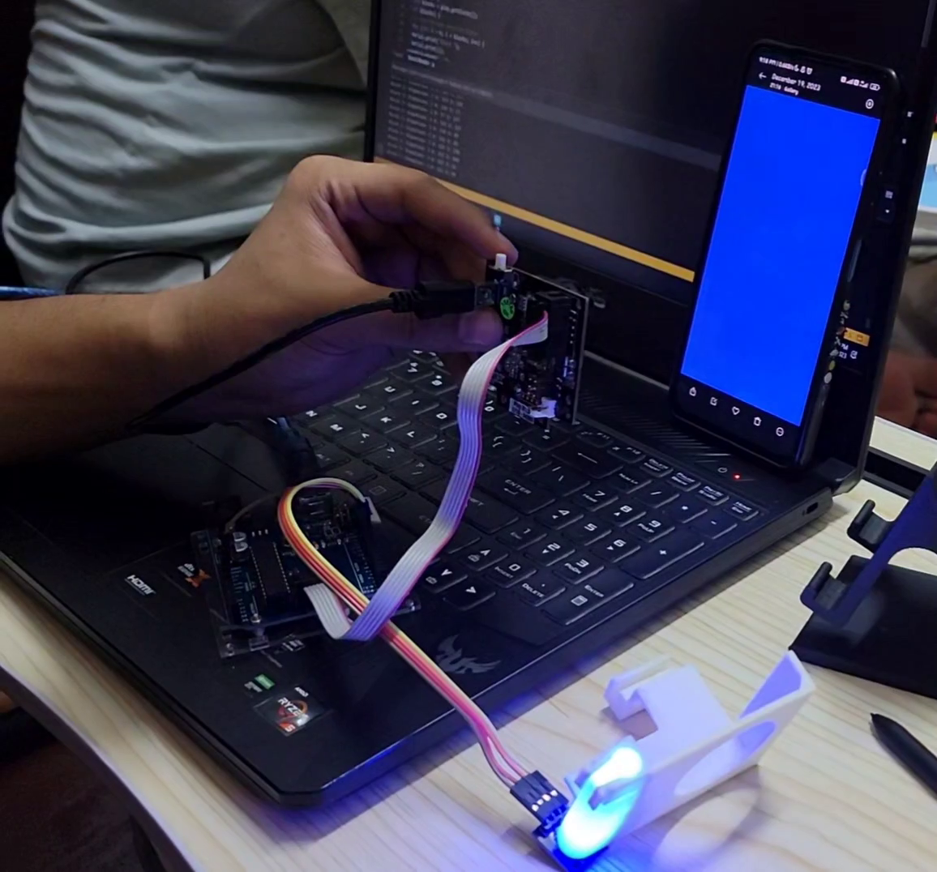

# **Results**



<https://github.com/NotLafuan/GROUP-F-MCTA-3203/raw/main/Week%209/Group%20F%20Week%209%20Part%20A.mp4>



<https://github.com/NotLafuan/GROUP-F-MCTA-3203/raw/main/Week%209/Group%20F%20Week%209%20Part%20B.mp4>

# 

# **Discussion**

**Part A**

Throughout the experiment, we have stumbled upon some difficulties in operating our colour detector, when it keeps lagging or does not compute any responses after a series of changes in colour detection.

For example, bright colours such as red are easily detected but when changed to blue or green, it stops providing response in the serial monitor so we have to keep resetting it. After some research, we found out that the error may be caused by low intensity or saturation of light. Colours with lower intensity of light tend to be harder to detect by the colour sensor.

Other than that, we can see that the colour sensor has some trouble to clearly differentiate the contrast colours due to the reason that it sometimes classifies the colour red as green, blue colour as green and gives out the wrong value for r, g and b.

This problem may be caused by interference with other light sources or an uncalibrated sensor. The reflective surfaces or glare in the view of the sensor might cause interferences in the colour readings. After calibrating it and minimises light interferences the sensor could work better than it was before.

Another cause for it not to work may also be caused by sensor degradation or ageing. Over time, sensors may degrade or age, leading to changes in their performance. Regularly check and replace sensors if needed to maintain accurate colour detection to avoid obtaining inconsistent readings.

**Part B**

During the experiment we had trouble to operate the Pixy Camera because we may received a damaged pixy camera since the resolution of the video was too bad. Turns out there was no cover on the cap of the lens when we received it. So, we borrowed another Pixy Camera from a different group to operate the experiment.-

Other than that the lagging during colour detection by the Pixy Camera may be caused by incorrect color signature setup where the color signatures may not be accurately in PixyMon. To solve it, we double checked and reconfigure the color signatures and make sure the taught color signatures matches the actual colours of the objects.

# **Conclusion**

In the conclusion, we manage to use both TCS230 colour sensor and a pixy camera to detect the primary colour (Red,Blue and Green). The output of the colour sensor and pixy camera were use as the input to light up the RGB Led.

From this experiment, we learn that colour sensor can be implement in the manufacturing line to detect colour of product on the conveyor and sorting it production items accordingly.

We also can implement the Pixy camera to distinct different types of item more accurately as it has the integrated software that learns about the details of a subject overtime by the assigned signature. It is even able to display the learned signature by name that is given.

# **Recommendations**

During conducting the experiment for Part A, we have been using TCS230 colour sensor.The improve the function of the colour sensor in the future, we might consider to implement Machine Learning techniques in our code.The main purpose is to widen the range detection by using the dataset that we put in the Arduino.

Calibration is also one of the important factor that we considering to improve our experiment.The TCS230 colour sensor may be calibrated by taking average RGB values from a black and white surface, subtracting these averages from the corresponding raw readings while the sensor is operating, and fine-tuning as necessary to achieve correct colour recognition in a particular setting.

Since the external factor light the level of light from surrounding also affect the result of colour sensor, so instead of using fixed threshold for the colour threshold we plan to use the dynamic threshold to improve the reading in all condition.

The second part of the experiment, Part B we have been using a pixy camera to detect the colour.The recommendation to improve this experiment is to using the advantage of pixy camera to detect multiple colour simultaneously.

In order create the system that actively track and follow detected objects or colours we might consider to integrate the system with the implementation of servo motor.The servo motor can be control through the utilisation Pixy2 API Features.

-calibrate sensor

# **References**

<https://howtomechatronics.com/tutorials/arduino/arduino-color-sensing-tutorial-tcs230-tcs3200-color-sensor/>

<https://dronebotworkshop.com/pixy2-camera/>

# **Appendices**

# Code Snippets

Part A

#include <SoftwareSerial.h>

#define R_PIN 11

#define G_PIN 10

#define B_PIN 9

SoftwareSerial colorSensor(3, 2);

long start = 0;

int colors[4];

int i = 0;

void normalize_colors(int colors[4]);

void setup()

{

colorSensor.begin(9600);

Serial.begin(9600);

pinMode(R_PIN, OUTPUT);

pinMode(G_PIN, OUTPUT);

pinMode(B_PIN, OUTPUT);

pinMode(12, OUTPUT);

digitalWrite(12, LOW);

}

void loop()

{

if (millis() - start > 500)

{

colorSensor.write("AT+FRE\r\n");

i = 0;

start = millis();

normalize_colors(colors);

analogWrite(R_PIN, colors[0]);

analogWrite(G_PIN, colors[1]);

analogWrite(B_PIN, colors[2]);

for (size_t i = 0; i < 3; i++)

{

Serial.print(colors[i]);

Serial.print(" ");

}

Serial.println();

}

if (colorSensor.available())

{

char data = colorSensor.read();

if (data == ':')

colors[i++] = colorSensor.parseInt();

}

}

void normalize_colors(int colors[4])

{

float max = 0;

for (size_t i = 0; i < 3; i++)

if (colors[i] > max)

max = (float)colors[i];

for (size_t i = 0; i < 3; i++)

colors[i] = (int)((float)colors[i] / (float)max * 255.0f);

}

Part B

#include <Pixy.h>

Pixy pixy;

const int R = 8;

const int G = 9;

const int B = 10;

void setup()

{

Serial.begin(9600);

pixy.init();

pinMode(R, OUTPUT);

pinMode(G, OUTPUT);

pinMode(B, OUTPUT);

}

void loop()

{

int blocks = pixy.getBlocks();

if (blocks)

{

// Loop through detected blocks

for (int i = 0; i < blocks; i++)

{

Serial.print("Block ");

Serial.print(i);

Serial.print(": ");

Serial.print("Signature: ");

Serial.print(pixy.blocks[i].signature);

Serial.print(" X: ");

Serial.print(pixy.blocks[i].x);

Serial.print(" Y: ");

Serial.println(pixy.blocks[i].y);

// Detect Colour Blue

if (pixy.blocks[i].signature == 1)

{

digitalWrite(R, LOW);

digitalWrite(G, LOW);

digitalWrite(B, HIGH);

// Detect Colour Green

}

else if (pixy.blocks[i].signature == 2)

{

digitalWrite(R, LOW);

digitalWrite(G, HIGH);

digitalWrite(B, LOW);

// Detect Colour Red

}

else if (pixy.blocks[i].signature == 3)

{

digitalWrite(R, HIGH);

digitalWrite(G, LOW);

digitalWrite(B, LOW);

}

}

}

}

# **Student's Declaration**

**Certificate of Originality and Authenticity**

This is to certify that we are responsible for the work submitted in this report, that the original work is our own except as specified in the references and acknowledgement, and that the original work contained herein have not been untaken or done by unspecified sources or persons.

We hereby certify that this report has not been done by only one individual and all of us have contributed to the report. The length of contribution to the reports by each individual is noted within this certificate.

We also hereby certify that we have read and understand the content of the total report and no further improvement on the reports is needed from any of the individual’s contributors to the report.

We therefore, agreed unanimously that this report shall be submitted for marking and this final printed report has been verified by us.

Signature: Naufal Read

Name: Naufal Understand

Matric Number: 2110333 Agree

Contribution: Testing and Debugging

Signature: Aiman Read

Name: Aiman Understand

Matric Number: 2113571 Agree

Contribution : Programming

Signature: Nabil Read

Name: Nabil Understand

Matric Number: 2114577 Agree

Contribution: Circuit Design

Signature: Zakwan Read

Name: Zakwan Understand

Matric Number: 2111033 Agree

Contribution: Data Analysis

Signature: Che Read

Name: Che Understand

Matric Number: 21119075 Agree

Contribution : Discussion